VySkan
Product Name | 4G LTE Compact Vehicle Tracker
Product Model | VO-OBD
Stealth. Connectivity. Vigilance.
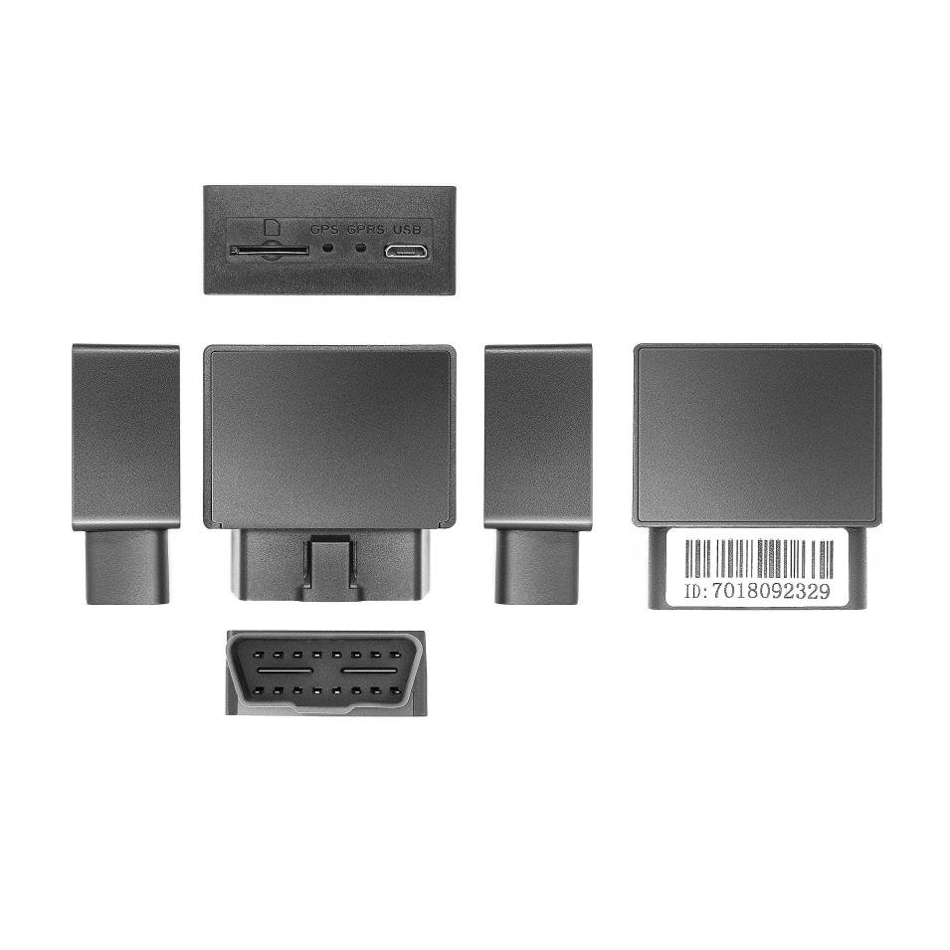
Engineered specifically for the European B2B telematics market, the VO-OBD is an ultra-compact 4G LTE tracker that delivers uncompromising security and real-time visibility. Its highly integrated, lightweight design makes covert installation effortless, perfectly suited for car rental agencies, auto-finance risk management, and enterprise fleet tracking where discretion is critical.

Core Value
- Ultra-Compact & Stealth Deployment
Body Dimensions just 53mm × 47mm × 23mm, the VO-OBD allows for highly concealed installations within confined vehicle spaces. This prevents visual detection and malicious tampering, safeguarding your high-value assets.
- Zero Data Loss Guarantee
Network blind spots? No problem. The built-in mass storage automatically caches telemetry data during cellular drops and seamlessly uploads it once the network connection is restored, ensuring 100% route and data integrity.
- Proactive Asset Defense
Equipped with comprehensive multi-alert systems including vibration, malicious power-cut, and over-speed alarms. The built-in 180mAh backup battery ensures you receive critical instant alerts even if the vehicle's main power is severed by thieves.

- Intelligent Power Management
A built-in 3-axis accelerometer enables a smart sleep/wake mechanism, dropping power consumption to under 10mA after 10 minutes of stationary time. It actively protects the vehicle's battery from draining while maintaining 24/7 standby defense.

Target Applications
- Car Rental & Leasing (Covert installation & asset security)
- Auto Finance & UBI Insurance (Risk management & anti-theft tracking)
- Corporate Fleet Management (Mileage & driving behavior monitoring)
- NEVs & Motorcycles (Compact size & intelligent power saving)

Technical Specifications
  - Cellular & GNSS
Category | Specification | Description
Network Bands | 4G LTE-FDD: B1/B3/B5/B7/B8/B20  2G GSM: B3/B8  (Global/Regional bands optional ) | Optimized EU frequency bands for reliable broadband connectivity.
SIM Card | Micro SIM | Push-push slot design.
GNSS Module | GPS + BDS Dual-mode | High-performance satellite tracking.
Positioning Accuracy | < 10 meters (1σ) | Pinpoint precision for real-time asset visibility.
Sensitivity | Tracking: -162 dBm | Maintains strong signal lock in dense urban environments.
Start Time | Cold: Avg 32s  Hot: Avg 1s | Rapid satellite acquisition supported by AGPS.
3.2 Power & Electrical
Category | Specification | Description
Operating Voltage | DC 9V - 45V | Wide voltage range compatible with standard passenger and commercial vehicles.
Working Current | Avg 40mA @ 12V | Standard active tracking mode.
Sleep Current | < 10mA @ 12V | Ultra-low power consumption mode.
Backup Battery | 180 mAh / 3.7V Li-Polymer | Ensures final alerts during unauthorized power disconnection.
3.3 Interfaces & Expandability
Category | Specification | Description
Smart Alarms | Vibration, Power-cut, Over-speed | Comprehensive built-in alerts for fleet safety and security.
Geo-fencing | Supported | Virtual boundaries trigger instant alerts upon entry/exit.
Smart Sensor | Built-in 3-axis Accelerometer | Detects vehicle posture, vibration, and manages sleep logic.
Audio | Microphone (Optional) | Supports voice monitoring.
3.4 Physical & Environmental
Category | Specification | Description
Dimensions | 53mm × 47mm × 23mm | Ultra-compact footprint for covert installation.
Weight | 45g | Extremely lightweight design.
Housing Material | ABS Plastic | Industrial-grade durability.
Operating Temp. | -20℃ to 75℃ | Reliable operation in varied climates.
Operating Humidity | 10% - 85% RH (Non-condensing) | Resilient in humid environments.

Built for Rapid Integration & Telemetry
We know hardware is only half the solution. The VO-OBD is designed to drastically reduce your Time-to-Market (TTM).
- Standard Protocols: Natively supports TCP/IP transmission for seamless backend communication.
- Supported Platforms: Seamlessly integrates with industry-leading tracking software including Wialon, Traccar, and enterprise custom dashboards without reverse engineering.
- API Ready: Comprehensive protocol documentation helps your IT team effortlessly parse location data and critical alerts (vibration, power-cut), achieving live dashboard connectivity in under 48 hours.
- A personalized service prepared for you
- 1× VO-OBD Sample Device (Pre-configured)
- Full API & Protocol Documentation
- 1-on-1 Technical Support from our Field Engineers
- Contact us
Website：https://vyskan.com/
Email: marketing@vyskan.com

